Quality Assurance
Applies to: Tower A v2 PINN
Guiding idea: Reproducible, debuggable, interpretable

0) Scope & principles
This plan governs how we:
- organize source code and file layout,
- run experiments and track configurations,
- record run-time provenance and artifacts,
- verify core physical properties,
- test changes quickly in CI, and
- debug failures predictably.
We intentionally avoid extra layers. Geometry is defined in code and remains the single source of truth. The TDT data pipeline is out of scope here (frozen or deferred). We reuse the working patterns already in the repo: unit-current training, seeded sampling, deterministic verifications, and simple slice visualization.
Design rationale.
A lightweight, visible pipeline lowers cognitive load and highlights faults early. We prioritize:
- transparency over abstraction (reviewable code over hidden state),
- instrumentation over speculation (logs and probes first),
- a small set of physics-relevant checks over broad test suites,
- fast CI gates over long, fragile end-to-end runs.

1) Repository hygiene & layout (light-touch)
Goal: predictable places for humans and scripts; no sys.path hacks in any script.
Canonical layout (by intent):
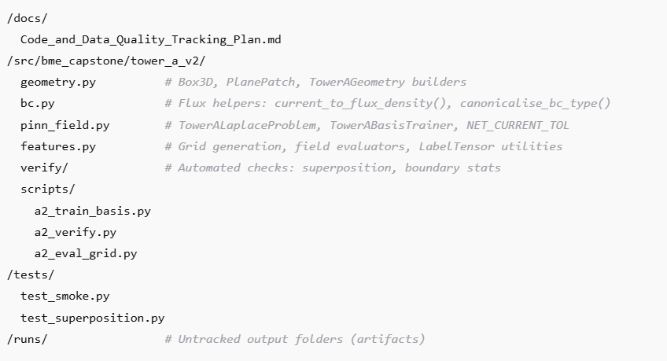
- /docs/ — living documentation (this plan), a one-page README summary, and any baseline metrics or acceptance thresholds.
- /src/bme_capstone/tower_a_v2/ — the importable package:
  - geometry.py — primitives and builders (e.g., Box3D, PlanePatch, TowerAGeometry) that describe the canonical Tower A geometry variants.
  - bc.py — boundary-condition helpers used across training and verification (e.g., current-to-flux conversions, type normalization).
  - pinn_field.py — the Tower-A Laplace problem, trainer wrapper(s), and constants like NET_CURRENT_TOL.
  - features.py — grid generation, field evaluation helpers, and labeled-tensor utilities for consistent evaluation and plotting.
  - verify/ — small utilities that implement the verification suite (physics checks and report assembly).
  - scripts/ — three single-purpose entry points:
    - a2_train_basis.py (train one basis),
    - a2_verify.py (run physics verification suite),
    - a2_eval_grid.py (evaluate φ/E on grids and export optional plots).
- /tests/ — smoke and superposition tests that run on CPU in under ~2 minutes.
- /runs/ — untracked per-run folders (created automatically by scripts and trainer).
Mapping from current repo.
Move the Tower A modules as-is into tower_a_v2 and shift the bespoke training/verification scripts into scripts/, preserving their proven behaviors (seeded runs, slice plots, net-current check). The goal is clarity; module names remain familiar.
Why this works.
The modules already separate geometry, BC helpers, training logic, and evaluation. Turning them into a clean, importable package eliminates path surgery and makes the behavior obvious to a new contributor.

2) Units & dimensions contract (mandatory)
Tower A operates in millimetre coordinates; to avoid silent inconsistencies, units are fixed project-wide:
- Spatial coordinates (x, y, z): mm
- Potential φ: volts (V)
- Electric field E = −∇φ: V/mm (because ∇ is in mm⁻¹)
- Electrical conductivity σ: S/mm (convert from S/m by dividing by 1000)
- Current density J = σ E: A/mm²
- Patch flux ∫ J·n dA: A (area in mm²)
- Flux density helper: returns A/mm² and expects area in mm²
Implications.
- All geometry and sampling contexts (areas, lengths) are millimetre-based by design.
- Any Neumann boundary condition expressed via current density must use A/mm².
- Any time σ is specified from literature in S/m, convert it once and store as S/mm.
- Verification reports should include units metadata for key values (e.g., "flux_units": "A", "residual_units": "V/mm²").
Adhering to this table prevents common 10³ or 10⁶ scaling mistakes in conservation and superposition checks.

3) Experiments & configuration (no config frameworks; geometry in code)
Each experiment is launched by a small command-line interface with a handful of explicit flags:
- electrode selection
- seed
- training controls (max epochs, patience, learning rate),
- sampling sizes (interior/contact/outer points),
- preset choice (smoke, default, thorough).
Geometry selection.
Experiments choose geometry by calling a named builder function in geometry.py. The function name and its input arguments are recorded in the run’s configuration snapshot. We do not hash files. The code is the contract and is reviewed like any other change.
Presets.
Three presets cover 95% of use-cases:
- smoke — very small model and budget for CI (sub-2-minute goal on CPU),
- default — standard internal work,
- thorough — longer runs for figures or baselines.
Each preset expands to a bundle of sampling sizes, epoch counts, and (optionally) early-stopping patience; they are documented in the CLI help and recorded verbatim in the run snapshot.
Why this succeeds.
The earlier version’s indirection obscured what changed. Recording the resolved CLI arguments, including the geometry function name and arguments, delivers transparent traceability with near-zero overhead.
Presets also define how often runtime health snapshots are emitted (e.g., every epoch for default, final epoch only for smoke

4) Run logging & minimal provenance
Every training or verification run creates a self-contained folder at /runs/<YYYYmmdd_HHMM>_<slug>_<shortsha>/. Each folder contains:
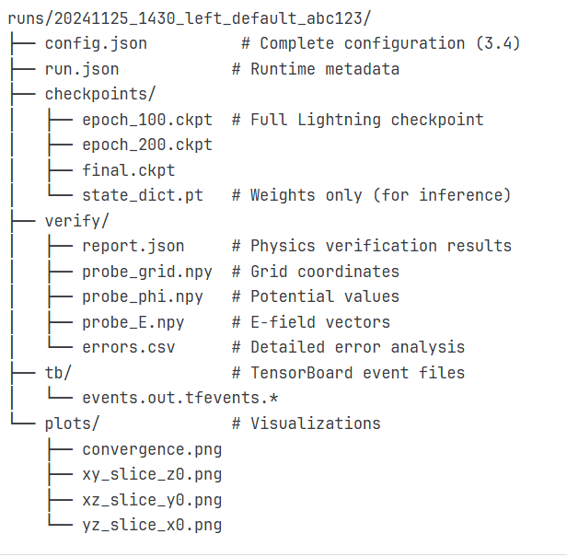
- Configuration snapshot (config):
  - script name and preset,
  - electrode(s), seed,
  - sampling sizes and modes,
  - solver choice (PINN is the default),
  - geometry function name and arguments (fully resolved),
  - trainer-relevant settings (e.g., early stopping, batch limits if used).
- Runtime metadata (run):
  - wall-clock times (total and per epoch), memory highs, exit status,
  - any early-stopping events or limiting flags used for CI.
- Model artifacts (checkpoints):
  - at least one human-readable final weights file for portability,
  - optional intermediate checkpoints if requested by the script,
  - note: do not track in git; keep in the run folder.
- Verification output (verify):
  - the consolidated verification report (see Section 5),
  - small arrays for probe coordinates and field values when saved,
  - any per-point error tables if exported.
- Trainer logs (tb):
  - scalar curves and any additional loggers used.
Sampling reproducibility.
Deterministic seeds are mandatory. For difficult cases, the scripts may also save actual sampled locations per condition; if locations are regenerated, they must be regenerated using the recorded seed and the same geometry and sampling arguments.
Why this is enough.
PINA’s trainer already captures the common metrics; the small, Tower-A-specific sidecars (configuration and verification) complete the provenance without introducing an external database or web service.

5) Runtime health-check & flow validation
Purpose. Catch issues while training—not just at the end—by continuously checking a small set of signals that reflect physics fidelity, numerical stability, units/sampling correctness, and data flow consistency. These checks are deliberately cheap and run on CPU or GPU without slowing iteration (small fixed probe sets, rolling medians, and counters).
When it runs.
- Pre-epoch ingress (once per epoch): geometry fingerprint, units sanity, sampling census, label/shape checks.
- In-epoch micro-checks (every k steps): finite-ness guards, residual trend medians/IQR, optimizer dynamics, boundary hit-rates, value-scale telemetry at micro-probes.
- End-of-epoch snapshot (always): concise “health” report saved in the run folder.
- Online physics spot-checks (cheap): superposition quick-check and net-current conservation quick-check each epoch.
What it records (by default):
- A tiny JSON health snapshot per epoch under:
/runs/<id>/health/epoch_<####>.json
containing: residual medians/IQR (interior & each BC), boundary compliance %, superposition (mean/p95) on a small fixed probe set, conservation mismatch vs NET_CURRENT_TOL, gradient/update medians, sampling hit-rates, φ/E ranges at micro-probes, and any NaN/Inf incidents.
Tripwires and actions (summary):
- Interior median rising → halve LR; re-check units (σ must be S/mm); ensure interior sampler active.
- One BC median flat/worse → increase that set’s samples; re-confirm BC type and outward normals; re-run conservation quick-check.
- Superposition p95 above cap with good residuals → add/confirm potential anchoring; ensure both fields evaluated on identical probes; re-check σ units.
- Conservation > NET_CURRENT_TOL → inspect per-contact flux; likely flipped normal or wrong area unit.
- NaN/Inf → capture batch indices and coordinates; retry with base PINN and lower LR; check for degenerate patch bounds.
- Boundary hit-rate starvation → raise boundary:interior ratio until medians improve.
Operator’s glance (traffic lights):
- PDE health (interior median): green/amber/red
- BC health (per set median): green/amber/red
- Linearity (superposition p95): green/amber/red
- Conservation (|net flux| vs tol): green/amber/red
CI usage. In the smoke preset, emit a single health snap

6) What the CLIs do (single-purpose, inspectable)
a) Training a basis field (a2_train_basis)
Intent. Train a single-electrode basis potential with clear, reproducible settings.
Behavior.
- Builds explicit geometry (volume and contact surfaces).
- Constructs the Tower-A Laplace problem using PINA’s abstractions.
- Enforces mixed boundary conditions appropriate to Tower A (contact patches driven through current density or flux; gauge/outer faces as specified).
- Trains a PINN solver using a fixed seed and the chosen preset, while logging residuals and boundary statistics in a standard way.
- Optionally evaluates φ and E on shared XY/XZ/YZ grids and writes plots for human inspection.
Outputs.
- A run folder with the configuration snapshot, metrics, checkpoints, and optional plots/grids.
Notes.
- Only expose the minimal flags. Any extra toggles should be grouped under an “advanced” section and default to current practices.
b) Physics verification (a2_verify)
Intent. Provide a fast, standardized suite that catches real errors.
Behavior.
- Trains or reuses three models (left, right, both) under the same seed.
- Performs a net-current conservation check at contact surfaces.
- Performs a superposition check on a fixed probe set (with optional potential anchoring).
- Summarizes boundary residuals and interior PDE residuals (median and dispersion).
- Emits a compact verification report for humans and for CI comparisons.
Outputs.
- A report file with pass/fail flags, summary statistics, units, and thresholds used.
- Optional per-point diagnostics (suppressed in CI).
c) Grid evaluation (a2_eval_grid)
Intent. Produce slice plots and field snapshots for interpretability, decoupled from training.
Behavior.
- Loads a chosen run’s model and configuration.
- Evaluates φ and E on cylindrical or Cartesian grids of interest (with documented extents and resolution).
- Exports plots and/or arrays in standard formats.
Outputs.
- A small subfolder of plots and, if requested, raw arrays with unit metadata.

6) Verification suite (physics-relevant, cheap)
The suite encodes just the physics that catch real mistakes in this project.
- Net current conservation (mandatory).
The sum of fluxes across all contact patches must equal the commanded total current within a tight tolerance.
- Integrate flux density as A/mm² over each patch area (mm²).
- Use geometry’s outward normals and ensure conductivity is expressed in S/mm.
- The tolerance constant (NET_CURRENT_TOL) is centralized; changes to it are rare and must be justified.
- Superposition (mandatory).
Because the problem is linear, the field produced by a combination of currents must equal the weighted sum of the basis fields.
- Evaluate on a fixed probe set to ensure comparability across runs.
- Optionally anchor the potentials to a single reference to remove constant offsets (which do not affect E).
- Report at least mean, 95th percentile, and maximum relative error.
- Boundary satisfaction summary.
For each named boundary condition (Dirichlet/Neumann sets), report the median residual and dispersion at the end of training.
- This exposes sign inconsistencies, mislabeled surfaces, or unit mistakes.
- Interior PDE residual.
Report the median and interquartile range of the interior Laplace residual on randomly sampled points (seeded).
- A runaway residual or extreme skew should trigger a quick investigation.
- Visual sanity (optional).
Slice plots of φ and |E| help spot non-physical asymmetries or leakage.
- Optional and not a CI gate, but invaluable during geometry moves.
Thresholds.
Initial thresholds are deliberately loose (e.g., superposition p95 ≤ 1–2% for smoke runs) and are tightened as baselines improve.
Why these checks.
They codify linearity and correct boundary handling — the two properties that routinely flag real defects — while staying cheap enough to run per PR.

7) Tests & CI (fast gates)
Philosophy. Quick, CPU-only checks catch regressions without slowing iteration.
- Smoke test (≤ ~60 s CPU):
Instantiates the geometry and problem, runs a handful of epochs on a tiny preset, verifies that residuals are finite and boundary residuals sit under a loose threshold.
- Superposition test (≤ ~90 s CPU):
Trains or loads left/right/both with tiny sampling, evaluates relative superposition error on a small probe set, and asserts it is under the smoke threshold.
- CI workflow:
  - Lint/type checks.
  - Run both tests on CPU with a strict time budget.
  - Optional “verify-physics” job on push that executes the verification suite with the smoke preset (still small and deterministic).
Practical notes.
- Keep the model small and the epoch count low in CI presets.
- Prefer trainer mechanisms that cap batches/epochs for the smoke job.
- Failing gates must point to a minimal, actionable log message (e.g., “superposition p95 exceeded threshold,” “net current mismatch exceeded tolerance”).

8) Metrics & promotion
Optimizing metrics (we aim to reduce these):
- Boundary residual median (by condition),
- Interior residual median,
- Superposition mean and p95 relative errors.
Satisficing metrics (must not regress beyond a band):
- Runtime per epoch (smoke preset),
- Peak memory footprint,
- Model size.
Baseline management.
- Maintain one tagged baseline run with its verification report and final weights archived outside git.
- Promotion requires passing all physics checks and showing a meaningful improvement (e.g., superposition p95 improves by ≥10% or convergence improves by ≥20% without accuracy loss) or a documented, reviewed trade-off.
Why this split.
It prevents engaging in wall-time optimization at the expense of physics fidelity and keeps review conversations grounded in visible benefits.

9) Debugging workflow (structured, minimal friction)
When a run misbehaves, follow this order:
- Replay exactly.
Re-run using the saved configuration snapshot (same geometry function and arguments, same preset and seed).
- If it cannot be reproduced, the issue is likely environmental; otherwise, proceed.
- Geometry & BC sanity.
List each contact’s name, center, area, and outward normal. Confirm that BC types are canonicalized correctly and that expected current signs match outward normals.
- The majority of “phantom” failures originate here.
- Sampling coverage.
Check counts per condition and confirm they match the preset. If boundary sampling is too sparse compared to interior, the solver may struggle to satisfy boundary conditions.
- Residual scale.
Inspect the trend of boundary and interior residual medians during early epochs. Exploding or flat-lining curves suggest either a unit mismatch or a wrong solver setting.
- For triage, always drop back to the base PINN before enabling attention/self-adaptive variants.
- Superposition diagnostics.
Compare left/right/both potentials at the same probe points (optionally anchored). If the mean error is acceptable but the tail (max) is high, examine that subset of points on plots to see if they cluster near a boundary or small contact.
- Visual inspection.
Examine the XY/XZ/YZ slices for asymmetry or leakage. Non-physical field patterns usually indicate a mislabeled surface or flipped normal, not a learning-rate issue.
Escalation.
If none of the above resolves the issue, construct the smallest geometry that exhibits the failure (e.g., two contacts and a gauge plane) and run the smoke preset to isolate the symptom.

10) Roles & change management
- Owners maintain the Tower A v2 package, scripts, and tests.
- PR checklist for changes to geometry, BC helpers, or solver defaults:
  - update the verification baseline if physics behavior changes,
  - keep seeds and tolerances unchanged unless there is a documented reason,
  - include a short rationale connecting code diffs to expected physics diffs.
- Breaking geometry changes must be called out in the PR description (function name and parameter changes) to alert any downstream usage.

11) Naming conventions (clarity > cleverness)
- Contacts/electrodes follow a stable, short scheme (e.g E_0_3, plus any fixed gauge surface).
- Run IDs use a time stamp, a short slug, and the git short SHA (for example, 2025-11-01_left_smoke_a1b2c3).
- Scripts are prefixed with a2_ for Tower A v2 and have descriptive names (train_basis, verify, eval_grid).
- Verification report keys use plain, lower-case names with units clarified alongside values where ambiguity is possible.

12) Data structures & technical conventions (PINA-aware, code-agnostic)
This section explains the core structures a new contributor will encounter, without code.
Labeled tensors.
Inputs and outputs are PINA labeled tensors (conceptually: tensors tagged with variable names, such as ["x","y","z"] for inputs and ["phi"] for outputs). Labeling allows PINA’s differential operators to be applied unambiguously and keeps the code readable. New contributors should assume:
- coordinates are always labeled in millimetres,
- the network’s output is labeled as potential (volts),
- gradients and Laplacians are computed through the labeled-tensor API.
Problems and conditions.
PINA problems organize:
- domains (interior and boundary subsets, e.g., contact surfaces and outer faces),
- conditions (PDE residual, Dirichlet values, or Neumann fluxes),
- discretization (sampling methods and point counts per domain).
Tower A’s problem class binds:
- the Laplace residual in the interior,
- a mix of boundary conditions on contact patches and outer surfaces,
- optional data-driven conditions if ever needed (not typical in v2).
Solvers.
The default is the PINA PINN solver. Self-adaptive or attention-weighted solvers remain optional tools for difficult conditioning scenarios; they are not the default. To maintain parity, the training loop is coordinated by PINA’s trainer (Lightning-based), which provides consistent logging and controlled accelerators.
Sampling.
Sampling parameters appear in presets and are recorded in the run’s snapshot. Coverage must be sufficient on boundary sets; boundary robustness improves when sampling is not dwarfed by interior points.
Geometry objects.
TowerAGeometry holds:
- a volumetric bounding box,
- a list of contact patches with names, areas, and outward normals,
- outer faces, including any gauge or grounded planes.
Conductivity.
Store a single number by default (homogeneous), in S/mm. For anisotropic or inhomogeneous extensions, route conductivity through explicit functions documented in the geometry or problem layer, and record those function names and arguments in the run snapshot (same pattern as geometry).
Seeds and determinism.
Scripts and tests must set seeds for all random sources. For CI and verification, seeds are the only acceptable source of determinism (no environment pinning here).

15) Acceptance thresholds (initial, to be tightened later)
- Superposition p95 relative error:
≤ 1–2% for smoke; ≤ 0.5–1% for default.
- Boundary residual medians:
Clear downward trend early in training; final values on the order of a few ×10⁻³ in the units corresponding to the boundary type.
- Interior residual median:
Should track boundary magnitude after early epochs; any large asymmetry must be explained in the report.
- Runtime budgets (smoke):
Full CI under ~2 minutes CPU; tests respect this by design.
Thresholds are periodically revisited once a stable baseline is established.

17) One-page README summary (for the main repo)
- Geometry is code. Tower A geometry lives in geometry.py. Function name + arguments are recorded in each run’s configuration snapshot.
- Two CLIs run everything. a2_train_basis trains one basis; a2_verify enforces physics (conservation, superposition, residuals). a2_eval_grid is for interpretability.
- Each run is self-contained. You will find config and run snapshots, checkpoints, logs, and verify reports in /runs/<timestamp>_<slug>_<sha>/.
- CI stays fast. CPU-only tests verify smoke training and superposition under tight runtime budgets.
- Debugging is predictable. Replay → geometry/BC sanity → sampling coverage → residual scale → superposition diagnostics → optional visuals → minimize to isolate.

Appendix A: Field inventory for run artifacts (human-readable, no code)
Configuration snapshot should include:
- Script and preset name,
- Seed value,
- Electrode/contact identifier,
- Sampling parameters (counts and strategy per domain),
- Solver choice and any deviations from defaults,
- Geometry:
  - function name,
  - function arguments (explicit, with units where applicable),
- Trainer options that affect determinism or runtime (e.g., early stopping, batch/event limits).
Runtime metadata should include:
- Git SHA and branch, and whether the tree was dirty,
- Device and framework versions,
- Start/end timestamps, total duration, and per-epoch average for the preset,
- Peak memory,
- Exit status and any early-stopping indicators.
Verification report should include:
- Units metadata (e.g., "flux_units": "A", "residual_units": "V/mm²"),
- Net current conservation: pass/fail, total flux mismatch (A), per-contact flux table, tolerance used,
- Superposition: pass/fail, mean/p95/max relative errors, probe count, and whether potentials were anchored,
- Boundary residuals: per-condition median and dispersion,
- Interior residuals: median and dispersion,
- Convergence summary: final losses and, if applicable, early-stopping epoch,
- Verdict for quick scanning in CI (PASS/FAIL).

Appendix B: Standard presets (described, not enforced)
- smoke: very small model, a few epochs, low sampling counts — good for CI and quick checks.
- default: moderate sampling, sufficient epochs to stabilize residuals — good for day-to-day experimentation.
- thorough: larger sampling and more epochs — reserved for baselines and publication-grade figures.
The exact numbers are encoded in the scripts and recorded in each run; treat them as tunable dials, but keep the smoke preset tight to preserve CI runtime.

Appendix C: Common failure signatures and likely causes
- Net current mismatch beyond tolerance:
Outward normals flipped; mis-labeled contact; units mismatch (σ not in S/mm; area not in mm²).
- Superposition fails with heavy tails (high max error but acceptable mean):
Probe points concentrate near corners or boundaries; boundary sampling too sparse; anchoring not used when comparing potentials.
- Boundary residual medians flat-line:
Incorrect boundary types; BC values expressed in wrong units; geometry function changed without updating contact names referenced elsewhere.
- Interior residual grows or remains large:
Solver instability; extreme class imbalance in sampling; latent unit mismatch between conductivity and field units.
- CI exceeds runtime:
Preset accidentally bumped; model too large; trainer not using batch/epoch limits for the smoke run.

Closing note
This plan intentionally avoids ceremony. It tells you where things live, what the scripts do, which facts each run must record, what gets checked, how we decide a model is good enough, and how to debug with minimal friction. When the project uncovers a new failure mode that costs real time, the next update here should be the smallest, clearest instrumentation or rule that prevents it from recurring.

